# Assignment 2

# Xin Chen, 45189915

**SCREENSHOT OF DESIGNER VIEW FROM PHPMYADMIN (You may put this in sideways if required)**

­­­­­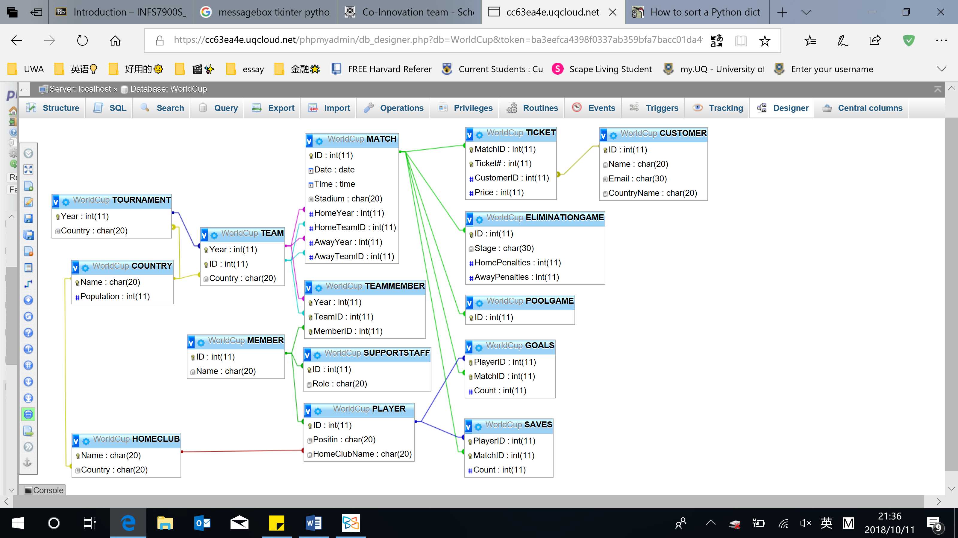

Query 1: Find all the Australian Players that played in the 2018 World Cup

QUERY SQL

SELECT DISTINCT P.ID

FROM PLAYER P, TEAMMEMBER TM, TEAM T

WHERE P.ID = TM.MemberID AND TM.TeamID = T.ID AND TM.Year = T.Year

AND T.Year = 2018 AND T.Country LIKE 'Australia'

QUERY OUTPUT (SCREENSHOT)

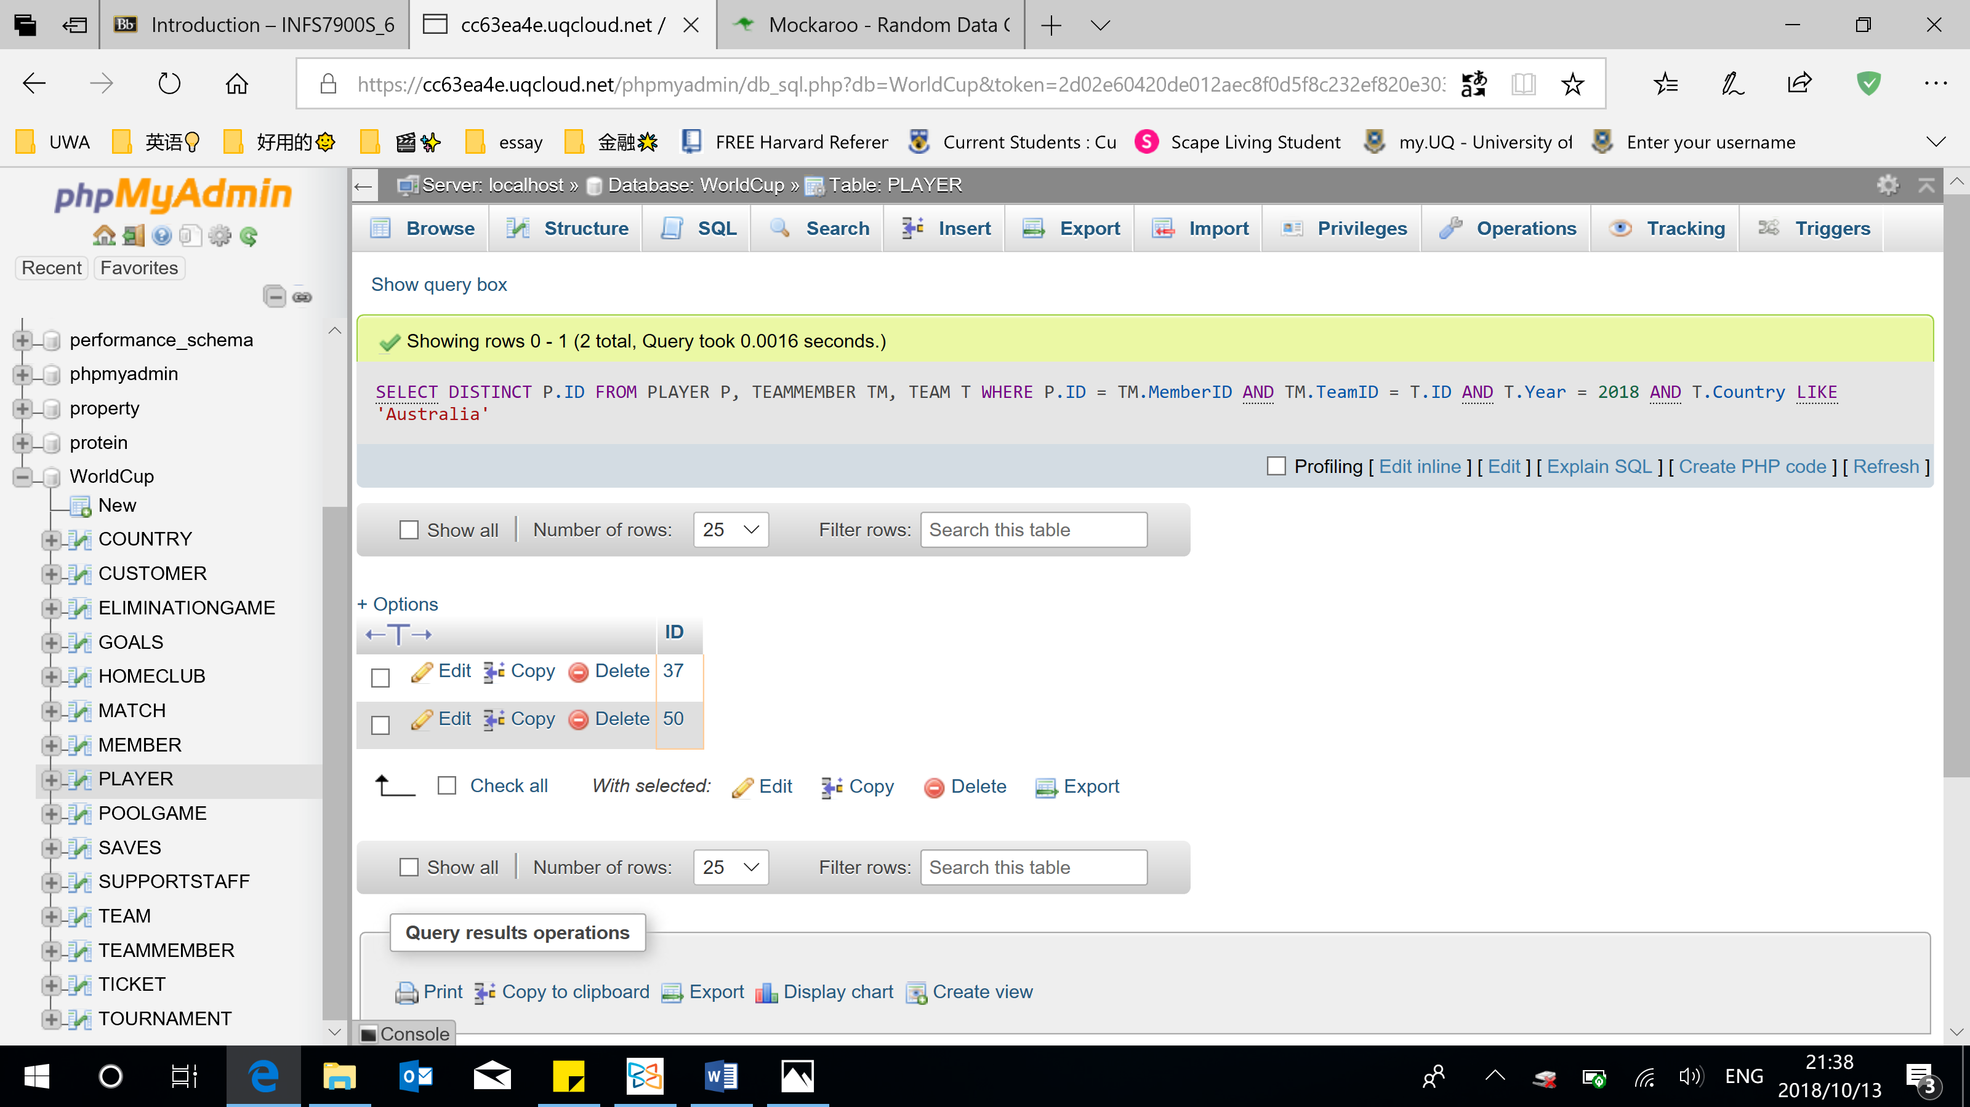

Query 2: Find the players that have never scored a goal

QUERY SQL

SELECT DISTINCT ID

FROM PLAYER

WHERE ID NOT IN(

SELECT PlayerID

FROM GOALS)

QUERY OUTPUT (SCREENSHOT)

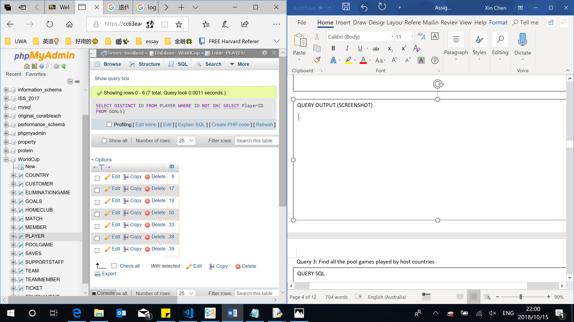

Query 3: Find all the pool games played by host countries

QUERY SQL

SELECT DISTINCT P.ID

FROM POOLGAME P, `MATCH` M, TEAM T, TOURNAMENT TM

WHERE P.ID = M.ID

AND ((M. HomeTeamID = T.ID AND M.HomeYear = T.Year AND T.Country = TM.Country)

OR (M. AwayTeamID = T.ID AND M.AwayYear = T.Year AND T.Country = TM.Country))

QUERY OUTPUT (SCREENSHOT)

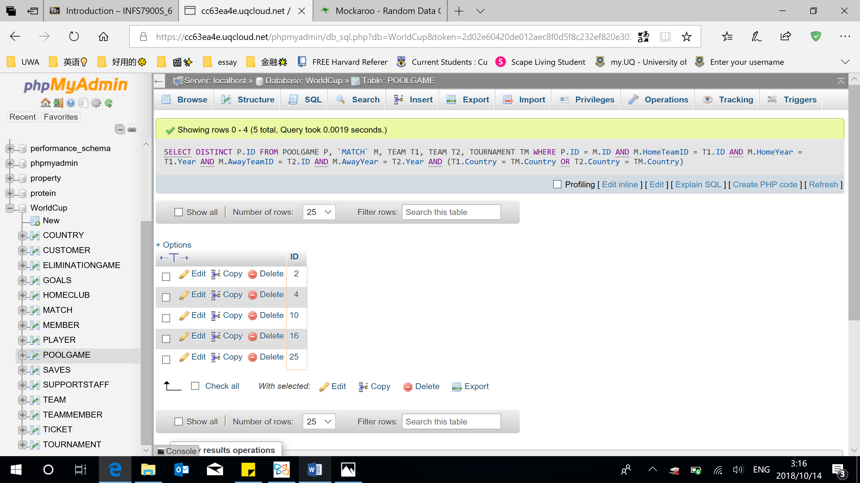

Query 4: Find all the Australian players linked to an English club team

QUERY SQL

SELECT DISTINCT P.ID

FROM PLAYER P, TEAMMEMBER TM, TEAM T

WHERE P.ID = TM.MemberID

AND TM.TeamID = T.ID

AND TM.Year = T.Year

AND T.Country LIKE 'Australia'

AND HomeClubName IN(

SELECT Name

FROM HOMECLUB

WHERE Country LIKE 'England')

QUERY OUTPUT (S CREENSHOT)

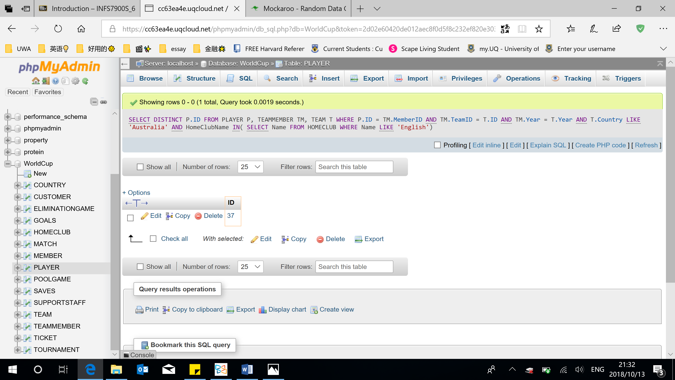

Query 5: Rank the teams by the number of support staff attending the 2018 World Cup

QUERY SQL

SELECT T.ID, COUNT(*)

FROM TEAM T, TEAMMEMBER TM, SUPPORTSTAFF S

WHERE S.ID = TM.MemberID

AND TM.TeamID = T.ID

AND TM.Year = T.Year

GROUP BY T.ID

ORDER BY COUNT(*)

QUERY OUTPUT (SCREENSHOT)

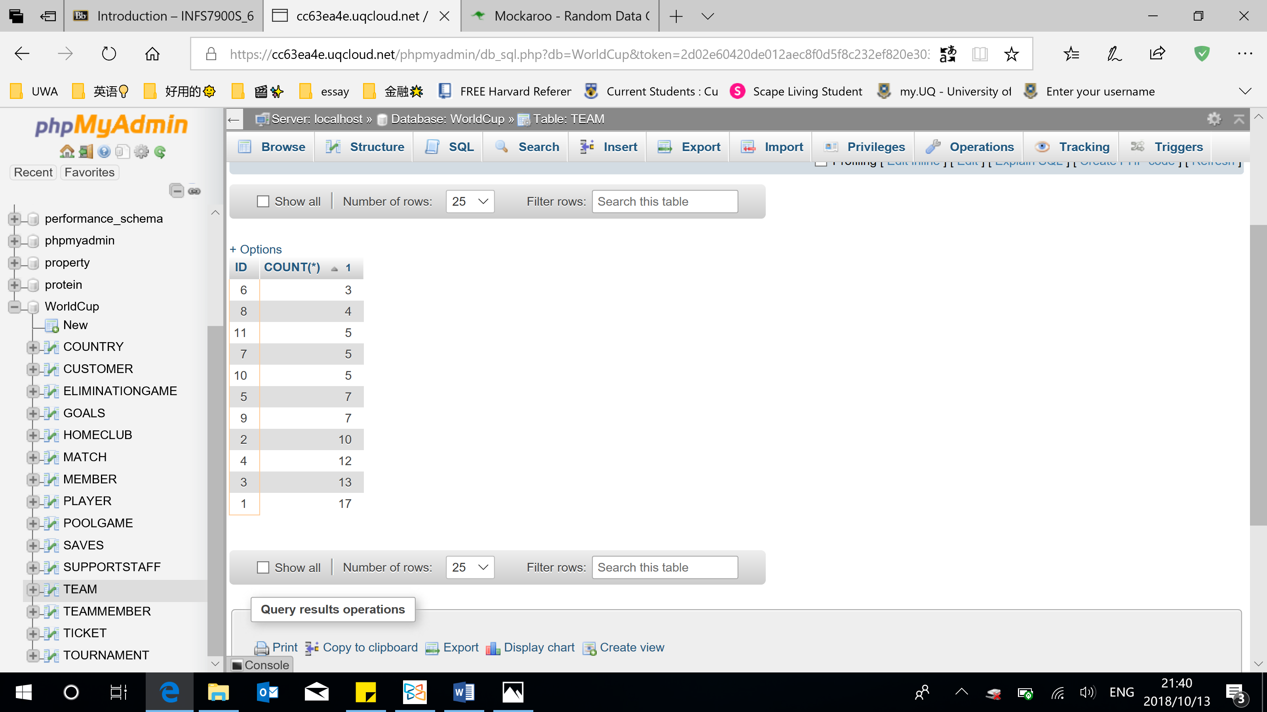

Query 6: Find the names & number of goals saved by all players

QUERY SQL

SELECT M.Name, SUM(S.Count)

FROM MEMBER M, PLAYER P, SAVES S

WHERE M.ID = P.ID AND P.ID = S.PlayerID

GROUP BY M.Name

QUERY OUTPUT (SCREENSHOT)

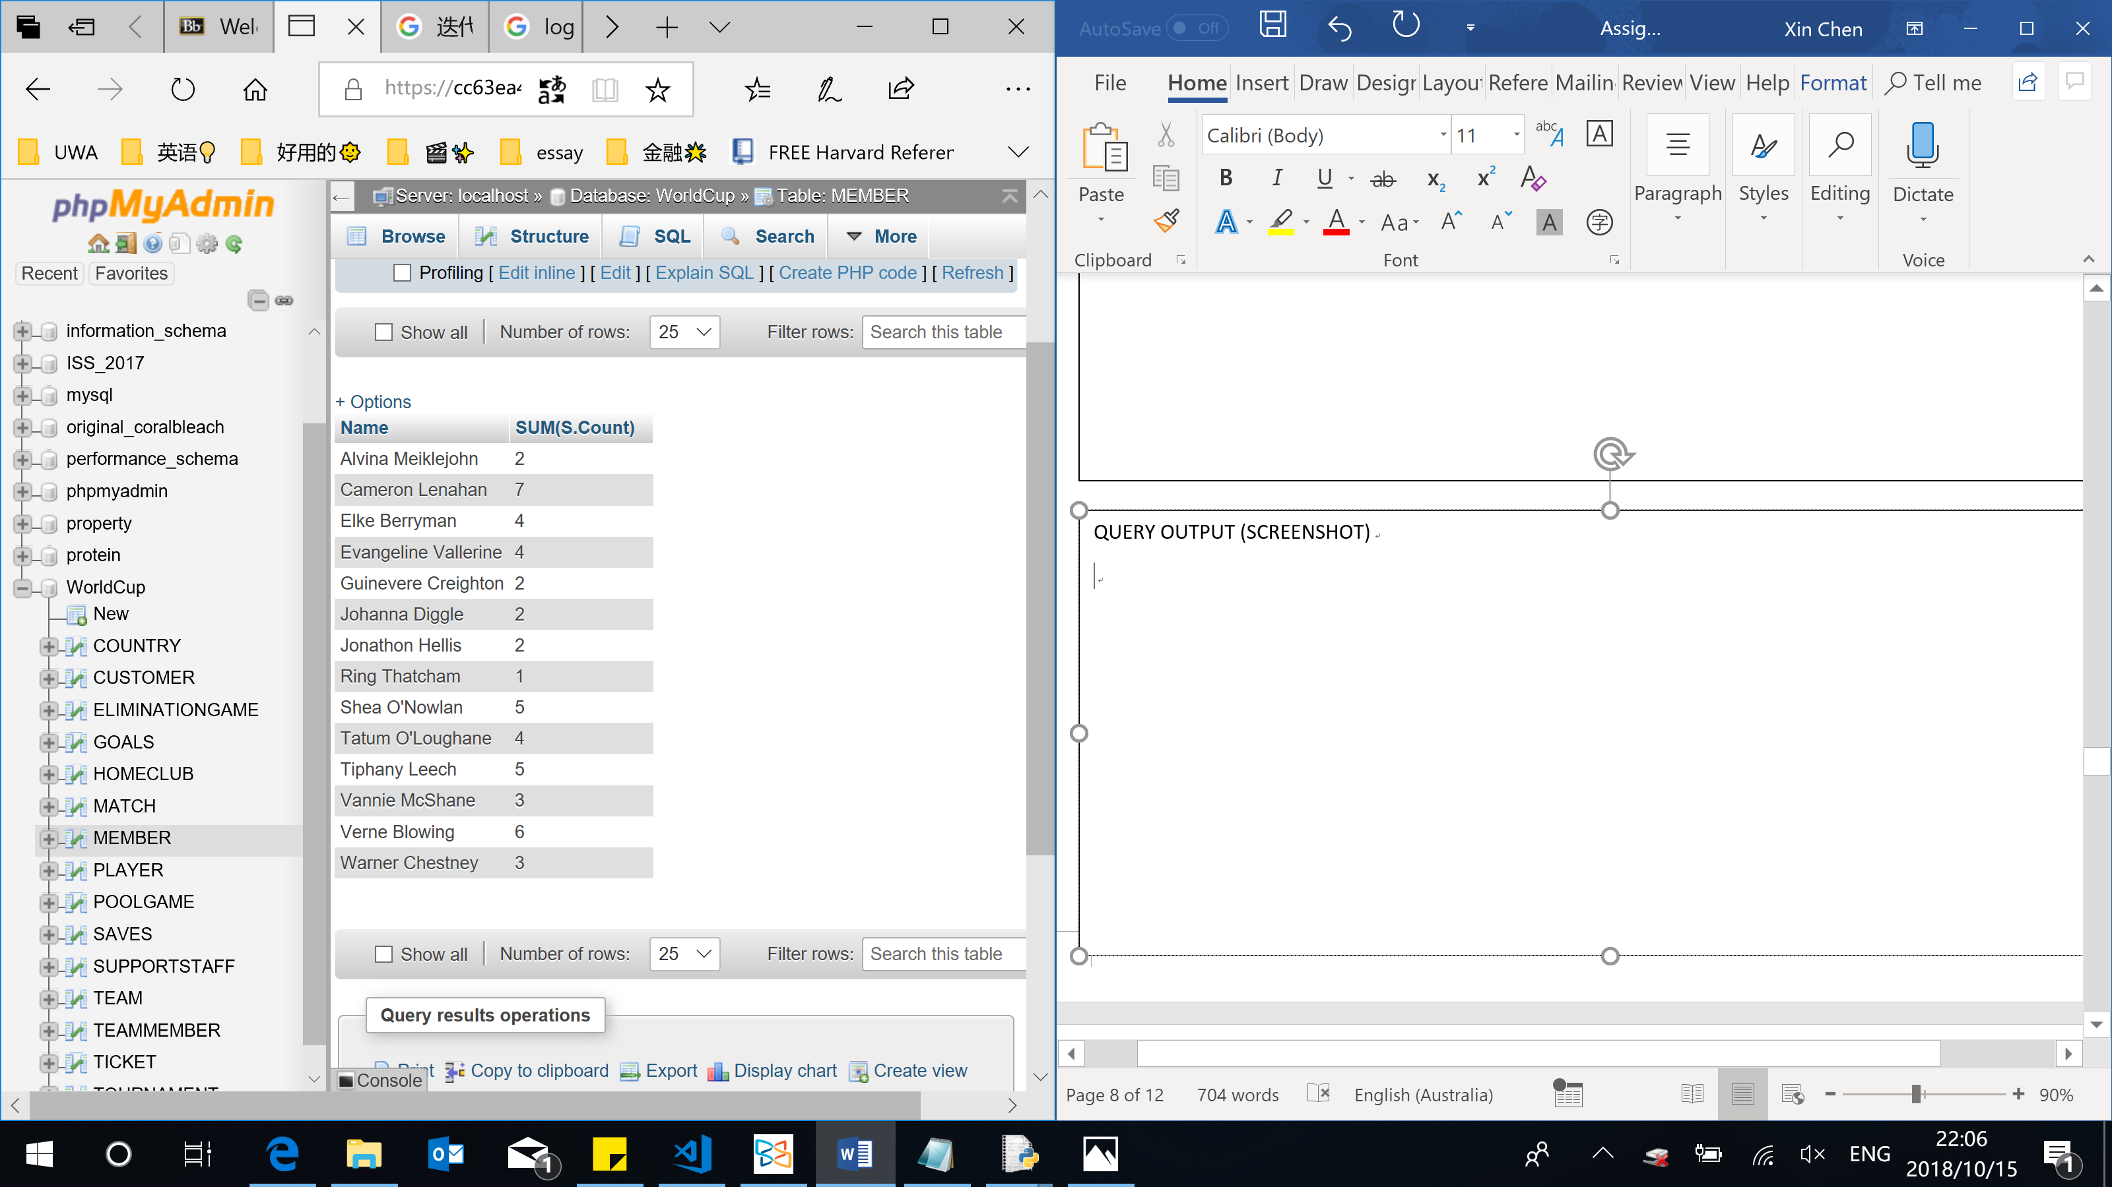

Query 7: Find the game that sold the most tickets

QUERY SQL

SELECT MatchID, COUNT(*)

FROM TICKET

GROUP BY MatchID

HAVING COUNT(*) >= ALL(

SELECT COUNT(*)

FROM TICKET

GROUP BY MatchID)

QUERY OUTPUT (SCREENSHOT)

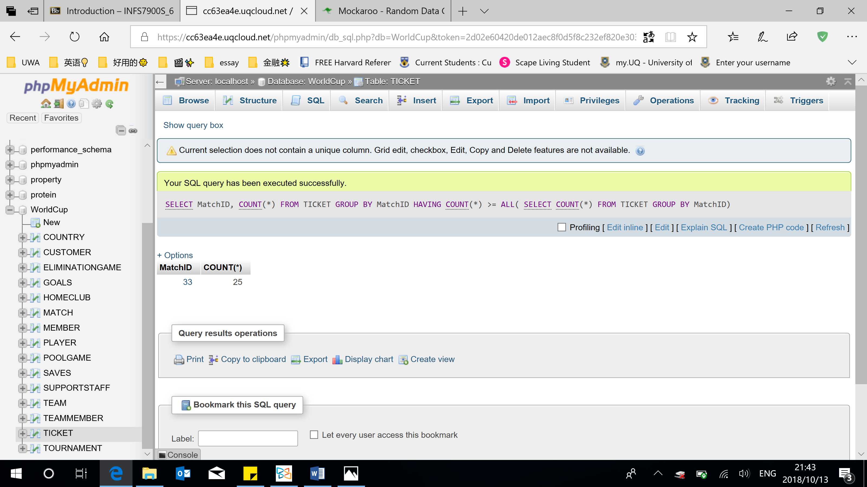

Query 8: Find the player who scored the most goals in elimination games

QUERY SQL

SELECT PlayerID, SUM(Count)

FROM GOALS G, ELIMINATIONGAME E

WHERE G.MatchID = E.ID

GROUP BY PlayerID

HAVING SUM(Count) >= ALL (

SELECT SUM(Count)

FROM GOALS G, ELIMINATIONGAME E

WHERE G.MatchID = E.ID

GROUP BY PlayerID)

QUERY OUTPUT (SCREENSHOT)

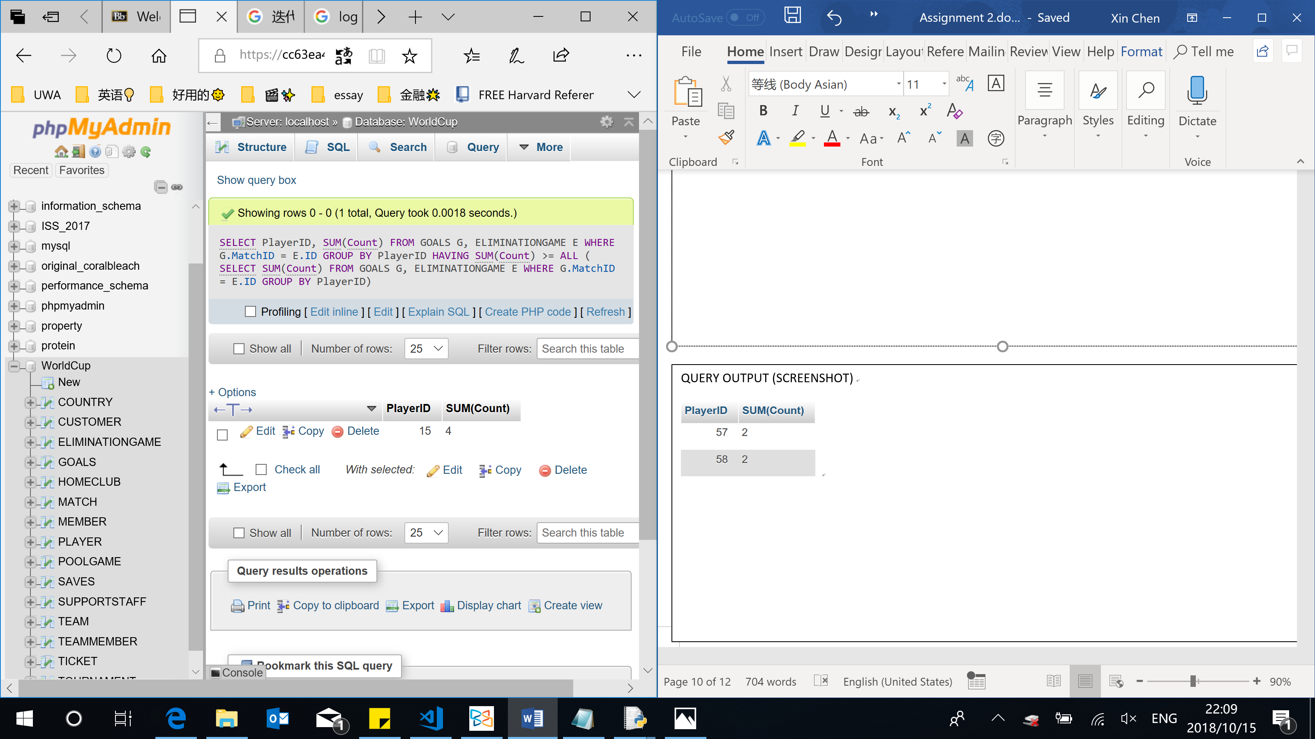

Query 9: Find countries that have played in all World Cups

QUERY SQL

SELECT DISTINCT Country

FROM TEAM T1

WHERE NOT EXISTS(

SELECT Year

FROM TOURNAMENT

WHERE Year NOT IN

(SELECT TN.Year

FROM TEAM T2, TOURNAMENT TN

WHERE T2.Year = TN.Year AND T2.ID = T1.ID))

QUERY OUTPUT (SCREENSHOT)

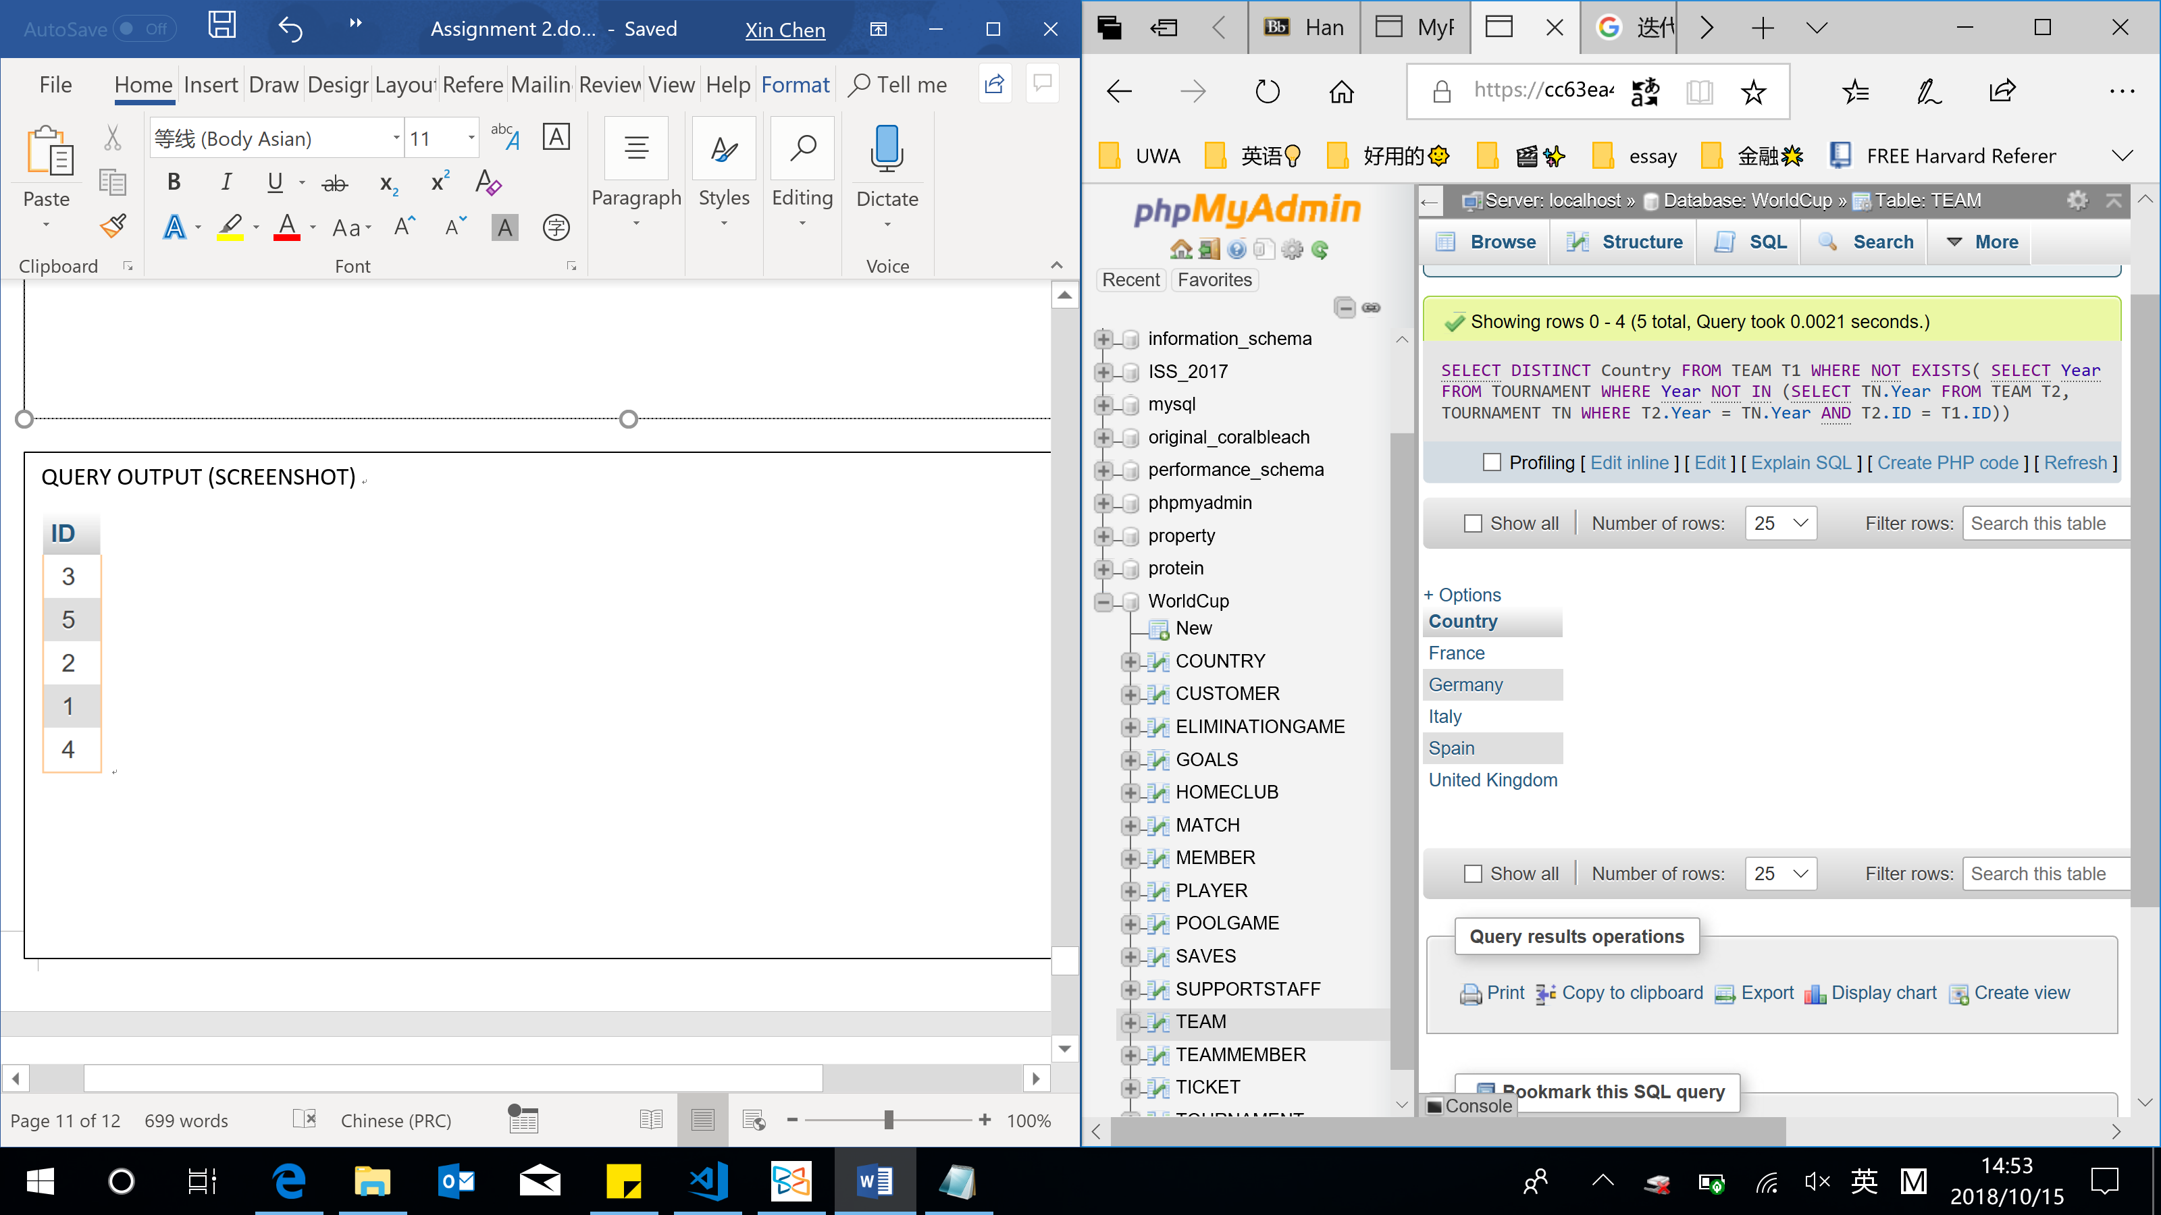

Query 10: Find players have scored goals in all of Iceland’s games

QUERY SQL

SELECT P1.ID

FROM PLAYER P1

WHERE NOT EXISTS(

SELECT M.ID

FROM GOALS G, `MATCH` M, TEAM T

WHERE G.MatchID = M.ID

AND ((M. HomeTeamID = T.ID AND M.HomeYear = T.Year AND T.Country LIKE 'Iceland')

OR (M. AwayTeamID = T.ID AND M.AwayYear = T.Year AND T.Country LIKE 'Iceland'))

AND M.ID NOT IN(

SELECT M.ID

FROM GOALS G, `MATCH` M, PLAYER P2, TEAM T

WHERE G.MatchID = M.ID AND P2.ID = G.PlayerID

AND ((M. HomeTeamID = T.ID AND M.HomeYear = T.Year AND T.Country LIKE 'Iceland')

OR (M. AwayTeamID = T.ID AND M.AwayYear = T.Year AND T.Country LIKE 'Iceland'))

AND P2.ID = P1.ID))

QUERY OUTPUT (SCREENSHOT)

